**GIT :**

Git is a distributed version control system that is widely used for tracking changes in source code during software development.

**GitHub:**

* GitHub is a web-based platform built around Git.
* It provides hosting for Git repositories and offers additional features for collaboration, such as issue tracking, pull requests, code review tools, and project management.
* GitHub allows developers to share their code, contribute to open-source projects, and collaborate with others on software development projects.

**Difference between Git and GitHub :**

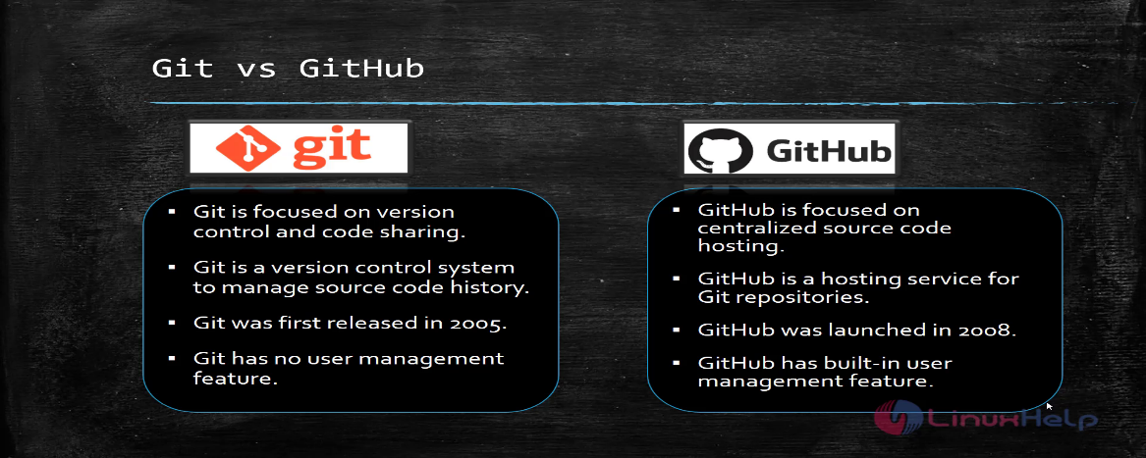

**Git Commands :**

1. **git init**: Initialize a new Git repository in the current directory.
2. **git clone <repository URL>**: Clone a remote repository to your local machine.
3. **git add <file>**: Add a file or directory to the staging area for the next commit.
4. **git commit -m "<commit message>"**: Commit staged changes with a descriptive message.
5. **git status**: Check the status of the working directory and staging area.
6. **git pull**: Fetch and merge changes from the remote repository into the current branch.
7. **git push**: Push commits from your local repository to the remote repository.
8. **git branch**: List, create, or delete branches.
9. **git checkout <branch>**: Switch to a different branch.
10. **git merge <branch>**: Merge changes from a specified branch into the current branch.